**Lecture Time Table Scheduler using Genetic Algorithm**

Sagar Madan

Department of Applied Mathematics

Delhi Technological University

Sagar Taneja

Department of Applied Mathematics

Delhi Technological University

Sameer Madan

Department of Applied Mathematics

Delhi Technological University

Abstract -- Lecture time-tabling preparation has always been known as a typical scheduling problem that is time consuming, energy sapping and often leading to general apathy and waste of resources. Planning time-table every session or semester is among the most complex and error-prone task carried out in higher institutions of learning. Therefore, the need to adopt an electronic system as opposed to the manual process cannot be over-emphasized. Several other administrative sectors of most institutions have been automated, but lecture time-tabling is still done manually because of its inherent problems. Planning lecture time-table demands enormous attention and effort from any institution because of its constraint satisfaction problem.

This study developed an electronic lecture time-table scheduler (ELTS) using Genetic algorithm to provide convenience in fixing classes and reduction in the risk of omission and clashes of courses, halls and lecturers.

* + - 1. Introduction

Lecture time-tabling system is a system that schedules lecture time and available resources in order to maximize such resources [1],[2]. It is one the most important yet time consuming task done periodically in any academic institution of learning. Therefore lecture time table should be carefully assigned into appropriate timeslot for students, lecturers and lecture halls based on constraints [3]. The manual lecture timetabling in our case study is done centrally and not on school (faculty) basis or departmental basis as obtained in several other institutions. This method is employed in order to manage the limited resources optimally in term of lecture halls. Data are collected from various departments in each school for the preparation. The timetable process is in three phases namely: Data collection from departments, where each department will supply the various courses which will include the course title, course code, contact hour (lectures and practical), course unit and the lecturer to take them. The second phase is the analysis of the provided data where the data supplied by the departments are analyzed with the available space [hall sizes]. The last phase is the Lecture time scheduling. Based on the analysis in the second phase, the lecture time-table is produced with three outputs vis-à-vis: Hall time-table [omnibus/main control], Departmental Input and Lecturers time-table [control II].

In scheduling the lecture time table, the following constraints must be taken into consideration; No student can attend more than one lecture at a time, No lecturer can teach more than one course per time and lecture hall cannot be assigned to more than one particular course at a time.

The problem of time-table scheduling is an optimization problem, a non-polynomial hard (NP hard) problem which implies that, there are no exact algorithms to solve the problem. Although, there are several techniques employed in literature for solving NP hard problem such as Evolutionary Algorithms (EA), Generic Algorithms (GA), Heuristic Algorithms (HA), and others, this study adopted the Genetic Algorithm approach to solve the problem at hand in our case study.

The scope of work is limited to space allocation for lectures and merging of similar courses for a particular lecturer.

* + - 1. Literature Review

A. Lecture Time-Table Scheduling Problem

The manual lecture time-table scheduling requires considerable time and effort with a lot of paperwork. The process involves assigning courses, lecturers and resources such as lecture halls to timeslots subject to constraints [1], [4]. The committee saddled with the responsibility of manual timetabling generation are usually faced with numerous challenges ranging from erroneous computation, clashes in lecture halls, omission of courses just to mention a few. It has been noted that space management in educational institutions is more critical compared to other institutions [5]. Therefore, management of space and facilities within an organization is paramount and must be dealt with efficiently.

The following resources and time slot exist as follows:

A set of lecturers {t1, t2…tn}

A set of courses {c1, c2,….cm}

A set of lecture-halls {r1, r2,…..rq}

A set of time {p1, p2, ….ps}

This attempts to arrange classes suitable to the lecture-halls such that no lecturer will be allocated in two classes at the same time [8]. This approach in scheduling timetable may solve several constrictions such as courses that have various time, joint courses, the distribution of courses in a week and lecture halls required.

With the increase in the number of student population, new programmes being mounted and additional lecture halls, an electronic lecture time-table scheduler is required to cater for this increase. Most of the time-tabling problems belong to the class of NP-hard problems, as no deterministic polynomial algorithm exists. Timetable is defined as the total schedule of specific lectures attended by a group of students in an institution and the lecturer at a specific time. It also requires specific resources such as lecture halls and so on [8]. Computational methods used to solve time-tabling include Tabu Search, Simulated Annealing, Evolutionary Algorithms and Artificial Intelligence [9]. Quite a number of papers employed generic algorithm for electronic time-table scheduling [10]. A study by [11] noted that Evolutionary Algorithm and Generic Algorithm only outperform methods such as hill-climbing when dealing with complex or resource starved time table problems. Professional software currently available for ELTS lacks the generality required by different institutions [10].

B. Hard and Soft Constraints

Time table constraints are grouped into hard and soft constraints. Hard constraints are those constraints that needed to be satisfied. In our case, some of such constraints are;

• Students can only be allocated to one class at a time

• Lecturers can only be allocated to one class at a time

• Venues can only be allocated for one class at a time

• Courses with same course title, code, content and same lecturers should be merged and fix in the hall with same capacity as the class size

• Practical for ICT-related courses must be allocated between 8am-2pm

The Soft constraints are desired requirements that do not necessarily had to be fulfilled. Although, it should be noted that sometimes, it might be important to satisfy soft constraints.

Some of the soft constraints in our study include;

• Lecturers should not go for more than 4 hours at a stretch

• Students should have some free periods between lectures

• Certain courses are to be taken in particular period.

• Certain periods within the week are to be free for all lecturers and students.

C. Genetic Algorithm

Genetic algorithm is a technique that is able to get an appropriate solution to search problems when the search space is complex and large. It has become the most preferred optimization technique of choice because it often succeeds in getting the best optimal solution as opposed to other common optimization algorithms. The algorithm employed biological method and genetic programming to solve problem. One of the advantages of GA is that they can explore solution space a multiple directions at once [12, 13]. The Genetic algorithm is

described in figure 1 below; [14]

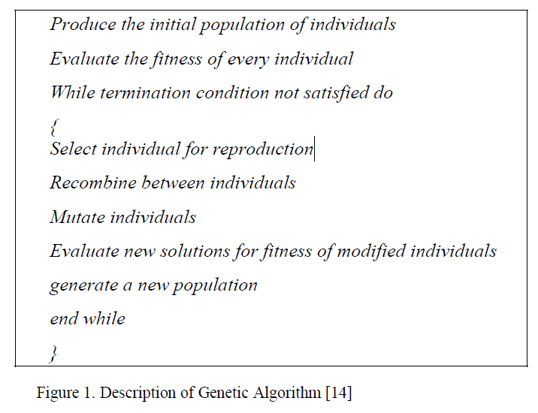

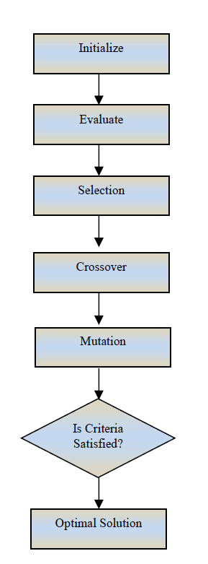

The genetic algorithm is made up of an iterative process, evolving an operational set of individuals (known as population) towards an objective function. This algorithm mimics the process of natural selection and is therefore considered a good method of solving this type of complex optimization problem of lecture time-table scheduling. The algorithm searches through the problem space defined by all possible encodings of solutions. Evaluation is performed to check the fitness of each solution in current population while selection picks individual for survival based on probability function of fitness. Crossover is a means of exchanging genetic materials, providing rules, features of machine learning, search or optimizing problem. Mutation has to do with change in gene composition of chromosome modification for single individuals.

III. SYSTEM DESIGN

The proposed model was built using the genetic algorithm after analyzing the manual process of time table scheduling; this is represented in figure 3. The first step in developing the software was to gather the required input from the committee involved in manual time table preparation. Data obtained include the number of lectures, venues and their capacities, student capacity per course, name of lecturers, courses and the units with hours of lectures and practical involved.

Java was the programming language used for the development of the back end and Microsoft SQL Server was employed for designing the back end. Also Adobe PDF reader or any other PDF reading software was used. The design of different forms required for user interaction was done and the interface was developed to be user friendly. The application developed was then tested and validated for efficiency and flow of operation.

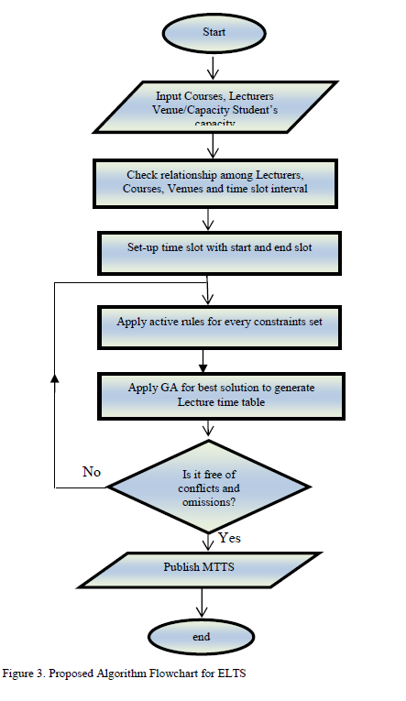

IV. SYSTEM IMPLEMENTATION AND STATISTICAL ANALYSIS

A. Software Implementation

Several constraints were taken into consideration in the software implementation. All the aforementioned hard constraints were put to use among which are; No student can attend more than one lecture at a time, No lecturer can teach more than one course per time and lecture hall cannot be assigned to more than one particular course at a time. In addition courses with same course code, title and at the same class level can be merged together to maximize space utilization. Figures 4, 5 and 6 are snapshots of generation of Time-table module, download module and module for the result of the ELTS generated and downloaded in PDF format.

**screenshots to be pasted**

V. CONCLUSION

At the end of the software development, an electronic lecture time-table scheduler was generated to overcome the shortcoming of manual time tabling system. This electronic system will simplify the manual process, ensure optimum allocation of resources and reduce the risk of omission of courses and clashes of halls and lecturers. The application software developed can be adapted and customized in other institutions of learning to ease the burden of the manual process. Also based on the statistical analysis of this study, electronic lecture time-table scheduler will be the best method to be adopted to ameliorate the issues associated with the manual process. This study therefore recommends the full deployment of this prototype and its implementation which will ease the burden of the manual process of time-tabling system and improve the academic activities within the institution.